A

Seminar Report
On
Driver Drowsiness Detection using CNN

Submitted by

Mr.Swapnil Mahajan
of B.E. (Computer Engineering- Course 2019) having Roll No. BA62 in partial fulfilment for the award of degree Bachelor of Engineering in Computer Engineering for AcademicYear2024-25
Under theguidance of

Prof.Supriya Kamble



DepartmentofComputerEngineering
Hope Foundation’s
InternationalInstituteofInformationTechnology,Hinjawadi,
Pune – 411057
SavitribaiPhulePuneUniversity,Pune

Hope Foundation's
International Institute of Information Technology,
Pune – 411057

Academic Year 2024-2025

Department of Computer Engineering
Certificate
This is to certify that, the Seminar Report entitled “Driver Drowsiness Detection using CNN ” submitted by Mr. Swapnil Mahajan, of Third Year having Roll No. BA62, is a bonafide student of this institute and completed the work under my supervision and guidance in partial fulfilment for award of degree of Bachelor of Engineering in the branch Computer Engineering of International Institute of Information Technology, Hinjewadi, Pune-411057.

Prof. Supriya Kamble
Seminar Guide

Dr. Ajitkumar Shitole Dr.Vaishali V. Patil
Head of Department Principal

Acknowledgment
I would like to express my special thanks to my internal guide Prof. Supriya Kambleas well as Dr. Ajitkumar Shitole, Head of Department who gave me the golden opportunity to do this seminar on the topic “Driver Drowsiness Detection using CNN”, which also helped me in doing a lot of research and I came to know about so many new things.
While doing this seminar, I had to take the help and guideline of some respected persons, who deserve our greatest gratitude. The completion of this seminar gives me much Pleasure. I would like to show our gratitude Prof. Mukesh More, Seminar Coordinator for giving me good guidelines for seminar throughout numerous consultations. I would also like to expand my deepest gratitude to all those who have directly and indirectly guided me in completing this seminar. Secondly, I would like to thank my friends for helping me with this seminar within the limited time frame.
I also extend sincere thanks to all the staff members of the Department of Computer Engineering and Dr. Vaishali V. Patil, Principal, for helping me in various aspects.

Mr. Swapnil Mahajan
CLASS:- BE(Computer Engineering)
ROLL NO. :- BA62

Abstract
Driver fatigue is one of the leading causes of road accidents worldwide, often resulting in serious injuries and fatalities. In recent years, technological advancements have paved the way for intelligent systems capable of mitigating such risks by continuously monitoring drivers' behavior and alertness. This project presents a comprehensive and real-time Driver Drowsiness Detection System leveraging Convolutional Neural Networks (CNNs), which are well-suited for image-based classification tasks due to their ability to learn spatial hierarchies of features automatically.
The proposed system captures facial features through a webcam and analyzes key indicators of drowsiness such as eye closure and yawning. Using Haar cascade classifiers, the facial region and eyes are accurately detected and extracted. These regions are preprocessed through resizing and normalization before being fed into the CNN model. The CNN architecture consists of multiple convolutional layers, activation functions (ReLU), pooling layers, and dense layers that culminate in a softmax output layer capable of classifying states such as "Eyes Open", "Eyes Closed", and "Yawning".
The model is trained on a labeled dataset with thousands of images categorized into different drowsy and alert states. The training process is optimized using backpropagation and regularization techniques over several epochs to ensure high accuracy and generalizability. Once trained, the model is deployed in a real-time setting where it continuously evaluates webcam input and detects patterns indicative of drowsiness. A logic layer counts the number of consecutive frames with closed eyes, and if a predefined threshold (e.g., 10 frames) is exceeded, an audible alert is triggered to warn the driver.
This system not only ensures improved safety by providing timely alerts but also demonstrates the power of deep learning in creating smart applications for real-world problems. The model's lightweight implementation further enables its integration into mobile and embedded systems, making it feasible for in-vehicle deployment.

Contents

List of Abbreviations i

List of Figures ii

List of Graphs/ Tables iii

1.Introduction 1

2.Literature Survey 2

3.Motivations and Objectives 7

3.1 Motivation

3.2 Objectives

4.Details of design/technology/analytical and/or 11
experimental work

4.1 Problem Analysis and Conceptual Understanding
4.2 Dataset and Preprocessing
4.3 System Design and Architecture
4.4 CNN Model Architecture
4.5 Model Training and Evaluation
4.6 Real Time Detection
4.7 Results
4.8 Challenges
5.Conclusions and Future Work 19

5.1 Conclusion
5.2 Future Work
6.References 21
7.Annexure I 22

List of Abbreviations

Abbreviation | Full Form
- CNN | Convolutional Neural Network
- DNN | Deep Neural Network
- ReLU | Rectified Linear Unit
- MaxPool | Max Pooling Layer
- ROI | Region of Interest
- OpenCV | Open Source Computer Vision Library
- Colab | Google Colaboratory
- MSE | Mean Squared Error
- MAE | Mean Absolute Error
- TF/Keras | TensorFlow / Keras
- Flatten | Flattening Layer
- Dropout | Dropout Regularization Layer
- Dense | Fully Connected Layer
- Adam | Adaptive Moment Estimation (Optimizer)
- EAR | Eye Aspect Ratio (used in real-time systems)

List of Figures

Sr No | Figure Description | Page No
1 | Fig.4. 1.1 SDN Architecture | 10
2 | Fig 4.4.1 CNN Model Architecture | 11
3 | Fig.4. 6.1 Real-Time Detection | 17
4 | Fig 4.7.1 Accuracy and Loss Plot | 17

List of Table/Graphs

Sr No | Table/Graph Description | Page No
1 | Table 2.1 Summary of Reference Paper | 04
2 | Graph 7.1Plagarism | 22

CHAPTER 1
Introduction

Road accidents caused by drowsy driving are a significant global issue, contributing to a large number of traffic collisions and fatalities every year. Fatigue reduces a driver's attentiveness, slows reaction times, and impairs judgment—often without the driver being fully aware of their decreasing alertness. According to studies by road safety organizations, drowsy driving is as dangerous as driving under the influence of alcohol, making its detection and prevention a critical area of research in intelligent transportation systems.

Traditional methods for detecting drowsiness include monitoring steering wheel movements, lane deviation, and vehicle speed patterns. While helpful, these methods are indirect, vehicle-dependent, and can be easily influenced by road conditions or external factors. As an alternative, physiological and behavioral-based approaches—such as monitoring the eyes, mouth, and head movements—have shown to be more accurate and reliable indicators of drowsiness. With the rise of machine learning and computer vision, it has become possible to automate this process by analyzing facial features through a camera in real-time.

This project implements a Driver Drowsiness Detection System that uses deep learning, computer vision, and real-time video processing to identify drowsy behavior. The system captures facial images using a webcam and uses Haar Cascade Classifiers to detect the presence of the driver’s face and eyes. These regions of interest (ROIs) are then resized and passed into a Convolutional Neural Network (CNN) that has been trained to classify the input into one of four categories: Closed Eyes, Open Eyes, Yawning, and No Yawning. The CNN, designed for image classification, extracts spatial hierarchies of features using convolutional filters and pooling layers, and then maps these features to output probabilities through fully connected layers and a softmax classifier.

When the system detects that both eyes are closed for a defined number of consecutive frames, it interprets this as a sign of drowsiness and triggers an alarm to alert the driver. The alarm runs on a separate thread to avoid disrupting the real-time video feed, ensuring a seamless user experience. This solution is hardware-independent, requiring only a basic camera and speaker, and can be easily deployed in any vehicle.

Overall, this project combines machine learning, image processing, and real-time application design to address the critical issue of drowsy driving. It not only demonstrates the power of deep learning in solving real-world problems but also offers a practical implementation that can significantly improve road safety by alerting drivers before their fatigue leads to an accident.

The goal of this project is to develop an affordable, efficient, and accurate drowsiness detection system that can be integrated into vehicles to enhance driver safety. This report outlines the methodology, system architecture, model design, training process, and real-time implementation of the proposed solution.

CHAPTER 2

Literature Survey

2.1. "Driver Drowsiness Detection System Using CNN" – IJRAR21C1273
This research explores the development of a real-time driver drowsiness detection system leveraging Convolutional Neural Networks (CNNs). Recognizing the severe danger posed by drowsy driving, the authors emphasize a non-intrusive method focused on monitoring eye states—particularly the duration of eye closure—using image processing. The system employs Python, OpenCV, TensorFlow, and Keras to detect whether a driver's eyes are closed, sounding an alarm if closure exceeds a specific threshold. Data collection involved curating images of closed and open eyes from both humans and animals. The model is trained using positive and negative samples, which are normalized and resized before classification using weak classifiers like decision stumps, iteratively refined through boosting to minimize error. This paper stands out by presenting a lightweight, real-time system with practical applicability in embedded environments such as Android devices. It also discusses challenges like varying lighting conditions and proposes improvements over prior models using multi-layer perceptrons by transitioning to CNNs, which offer higher accuracy and robustness in visual recognition tasks.

2.2. "Drowsiness Detection in Real-Time via CNN and Transfer Learning" – Journal of Engineering and Applied Science, 2024​
This comprehensive study presents a highly accurate and practical driver drowsiness detection model built using CNN and transfer learning, designed to operate in real-time and even deployed as a mobile application. The authors explore multiple deep learning models and test them across various datasets (YAWDD, CEW, MRL, NTHU-DDD, etc.), achieving outstanding accuracy rates up to 99.86%. The architecture leverages pretrained models such as InceptionV3 and augments them with domain-specific training to enhance eye state classification. It implements both binary and multiclass classification to distinguish between eye states like open, closed, and yawning. In addition to traditional CNNs, the authors use Grad-CAM visualization to understand model predictions better and test robustness across lighting conditions. Their method includes novel dataset aggregation strategies and a custom "eye state" dataset published on Kaggle. By integrating their findings into an Android-compatible app, the authors show the scalability of their approach from theoretical design to real-world implementation, especially useful in transportation safety.

2.3. "A CNN-Based Approach for Driver Drowsiness Detection by Real-Time Eye State Identification" – Applied Sciences, 2023​
This paper presents a focused CNN-based method for detecting drowsiness through real-time eye state classification. It uses three prominent CNN architectures—InceptionV3, VGG16, and ResNet50V2—on the NITYMED dataset, which features real-world nighttime driving conditions. The system uses MediaPipe for precise eye region extraction, applying transfer learning to improve detection accuracy. Notably, the ResNet50V2 model demonstrated superior performance with 99.71% accuracy. The study's standout feature is the innovative ROI correction method, which ensures accurate tracking even during head movement. The system monitors eye closure duration, classifying states based on a threshold (e.g., eyes closed > 300ms indicates drowsiness). Grad-CAM is used to visualize how the CNN interprets eye closure, aiding model transparency. The research focuses on improving usability in dynamic real-world environments by accounting for variations in facial angles and illumination, thus ensuring high reliability for deployment in automotive systems.

2.4. "Driver Drowsiness Detection Model Using CNN Techniques for Android Application" – Qatar University & CNAM​
This study presents a CNN-based lightweight drowsiness detection model explicitly designed for Android platforms and embedded systems. It builds on prior work using multi-layer perceptrons by adopting CNNs for improved efficiency and accuracy. The authors focus on capturing facial landmarks and classifying drowsy states using minimal computational resources. The model achieves over 83% accuracy across diverse conditions, including scenarios with and without glasses, during the day and night. It emphasizes reducing model size (only 75 KB), making it ideal for deployment on mobile devices. Video data is preprocessed to extract facial features using Dlib and OpenCV. The model is trained on the NTHU-DDD dataset, employing data augmentation techniques to enhance robustness. By integrating into Android systems with minimal hardware overhead, the study illustrates a scalable, accessible solution for driver safety that doesn't rely on expensive proprietary vehicle systems. The use of low-power, always-on wearable-compatible devices marks an innovation in portable drowsiness detection.

2.5. "Driver Drowsiness Detection System Using CNN" – IJSET, 2022​
This paper proposes a CNN-based system for real-time drowsiness detection using a dataset of 30,000 eye images. With an accuracy of 96–98%, the system identifies prolonged eye closure via webcam and alerts the driver with an alarm. The custom CNN architecture includes multiple convolutional layers followed by pooling and fully connected layers, utilizing ReLU and Softmax for activation. The model's architecture is optimized for computationally limited devices, making it suitable for embedded systems. The literature review extensively explores past methods like PERCLOS and emotion-based detection, comparing behavioral, physiological, and visual approaches. The paper emphasizes the importance of night-time adaptation and proposes further improvements by increasing dataset size. The authors argue for the broad applicability of their solution to various stakeholders, including commercial vehicle fleets and insurance firms, making this model a strong candidate for integration into broader intelligent transport systems.

Table 2.1 Summary of Reference Paper

Sr no | Name of paper | Journal published and year | Author | Summary
1. | Driver Drowsiness Detection Model Using Convolutional Neural Networks Techniques for Android Application | International Conference on Communication, Computing and Virtualization | Rateb Jabbar, Mohammed Shinoy, Mohamed Kharbeche, Khalifa Al-Khalifa, Moez Krichen, Kamel Barkaoui | Approach: The authors propose a CNN-based drowsiness detection framework tailored for Android devices. It uses facial landmark extraction (via Dlib) to analyze eye movement and facial orientation, classifying drowsiness in real-time using images from the NTHU-DDD dataset.  Innovation: Prioritizing computational efficiency, the model maintains a memory size of just 75 KB while achieving over 83% accuracy across multiple conditions (day/night, with/without glasses). The work bridges deep learning with mobile computing for accessible and scalable deployment.
2. | Driver Drowsiness Detection System Using CNN | International Journal of Science, Engineering and Technology (IJSET), Vol. 10, Issue 2, 2022 | Soumya Agarwal, Dr. M.N. Nachappa | Approach: A CNN model is trained on a dataset of 30,000 images to detect driver fatigue through eye state analysis using webcam input. The system uses a multi-layer CNN architecture, with convolutional and pooling layers feeding into fully connected layers, classifying eye openness in real-time.  Innovation: With an accuracy of 96–98%, the model provides timely audio alerts for closed-eye duration exceeding thresholds. It is designed for deployment on low-resource devices and emphasizes scalable safety applications for commercial vehicles and public transportation systems.
3. | Facial Region of Interest Based Driver Drowsiness Detection Using CNN Models | Applied Sciences (MDPI), 2023 | Wilson Florez, Miguel A. Rodriguez, Jeysson H. Pedraza, Juan C. Fernandez, Carlos E. Montenegr | Approach: A comparative analysis of CNN architectures (InceptionV3, VGG16, ResNet50V2) is presented for eye-state classification using the NITYMED dataset, with MediaPipe utilized to precisely extract eye regions. The model detects drowsiness by analyzing blink duration and frequency in dynamic, real-world scenarios.  Innovation: The research introduces a novel ROI correction method to maintain eye tracking accuracy during head movement. ResNet50V2 outperforms other architectures, achieving 99.71% accuracy, and visualization via Grad-CAM supports explainable AI in safety-critical applications.
4. | Driver Drowsiness Detection System Using CNN | International Journal of Research and Analytical Reviews (IJRAR), Vol. 8, Issue 3, July 2021 | Sushmita Prasad, Nihal Shaikh, Trushita Jadhav, Robin Sen, Pushkar Sath | Approach: The authors developed a real-time driver drowsiness detection system using Convolutional Neural Networks (CNNs) to analyze eye closure over time. By processing video frames through OpenCV and TensorFlow, the system detects prolonged eye closure and triggers an alarm, effectively translating temporal visual features into fatigue cues.  Innovation: They integrated boosting with weak classifiers (decision stumps) to iteratively enhance model accuracy, addressing common issues in traditional systems such as sensitivity to illumination changes. The model’s lightweight design makes it suitable for deployment on Android and embedded systems.
5. | Drowsiness Detection in Real-Time via Convolutional Neural Networks and Transfer Learning | Journal of Engineering and Applied Science, 2024 (Vol. 71:122) | Dina Salem and Mohamed Waleed | Approach: This study applies transfer learning with pre-trained CNN architectures (e.g., InceptionV3) to detect drowsiness by classifying eye states (open, closed, yawning) using datasets like YAWDD and MRL. The model processes diverse visual cues from facial images and achieves high generalization through fine-tuning on domain-specific datasets.  Innovation: The system achieves up to 99.86% accuracy in multi-class classification and includes a mobile application with a real-time alert system. Techniques like Grad-CAM are used to visualize feature attention, improving interpretability and model trustworthiness.

2.6 Summary of all papers
1. CNNs as the Core Technique for Drowsiness Detection
All five papers utilize Convolutional Neural Networks (CNNs) as the foundational model due to their superior performance in image-based classification tasks, especially in detecting eye states such as open, closed, and yawning. Whether trained from scratch or enhanced via transfer learning, CNNs prove highly effective in real-time fatigue detection by analyzing facial features.

2. Real-Time Monitoring Through Eye and Facial Analysis
The common detection strategy across studies is based on tracking the driver’s eye closure duration, often paired with blinking patterns or yawning detection. Systems trigger alerts (e.g., alarms or vibrations) when the eyes are closed beyond a threshold (typically 300ms+), identifying microsleeps and early signs of drowsiness.

3. Use of Diverse and Realistic Datasets
The studies employ datasets like NTHU-DDD, YAWDD, CEW, MRL Eye, and NITYMED, some of which include challenging real-world driving conditions such as low-light environments or head movements. This enhances model generalization and robustness, making the systems suitable for real-world deployment.

4. Mobile and Embedded System Compatibility
Several papers prioritize lightweight model architectures (some under 75 KB) for deployment on Android devices and embedded systems. These low-resource solutions aim to expand access to drowsiness detection beyond luxury vehicles, offering scalable safety solutions for public transportation, fleets, and personal cars.

5. Visual and Interpretive Enhancements
Advanced techniques like Grad-CAM are used to visualize and interpret CNN feature maps, improving model transparency and user trust. Some systems also use MediaPipe or Dlib to accurately extract eye regions even during head rotations, enhancing detection accuracy in dynamic conditions.

6. High Accuracy and Practical Application
All models achieve strong classification accuracy—ranging from 83% to over 99%, depending on architecture and dataset. Several projects culminate in functional prototypes or mobile apps capable of running in real-time, thus bridging the gap between academic research and deployable driver safety systems.
CHAPTER 3
Motivation and Objectives

3.1 Motivation
The increasing number of road accidents caused by drowsy or fatigued drivers has become a critical public safety concern. According to global traffic safety statistics, thousands of accidents occur annually due to driver drowsiness, many of which lead to severe injuries or fatalities. Fatigue-related crashes are often more serious because the driver does not make any attempt to avoid the accident—there’s no braking, no swerving—just a direct collision. What makes this issue more alarming is that signs of drowsiness are often subtle and go unnoticed by the driver themselves. Therefore, early and automatic detection of such signs can play a pivotal role in preventing accidents.
Human observation or self-awareness alone is not reliable for identifying drowsiness. While some commercial vehicles have started integrating sensor-based drowsiness detection systems, these are often expensive and based on indirect indicators such as steering behavior, lane keeping, or even heart rate sensors—approaches that can be inaccurate, invasive, or not adaptable across different vehicles. In contrast, non-intrusive, camera-based systems using facial behavior analysis offer a cost-effective and user-friendly solution, leveraging advances in computer vision and artificial intelligence to directly monitor the driver’s state.
The emergence of deep learning, particularly Convolutional Neural Networks (CNNs), has revolutionized image classification tasks. This technology provides the ability to train models to detect and recognize facial patterns like eye closure and yawning with high accuracy. Furthermore, CNNs offer flexibility to work in dynamic real-world environments, making them ideal for in-vehicle deployment where lighting conditions, head movements, and facial angles vary frequently.

  - Objectives
The primary objective of this project is to design, train, and implement a deep learning-based system capable of detecting signs of driver drowsiness in real time. The specific goals are outlined as follows:

- To develop a dataset and preprocess facial images into four distinct classes: Open Eyes, Closed Eyes, Yawning, and No Yawning, allowing the model to learn multiple indicators of drowsiness.

- To use Haar Cascade Classifiers for accurate face and eye detection in video frames, ensuring efficient and robust localization of regions of interest.

- To design a Convolutional Neural Network (CNN) that can classify preprocessed images into the defined categories with high accuracy, leveraging data augmentation and model optimization techniques.
- To implement a real-time monitoring system using a webcam, where the trained model continuously processes video frames to assess the driver’s alertness level.

- To raise a visual and audible alert when signs of drowsiness—such as prolonged eye closure—are detected, ensuring immediate attention from the driver.

- To maintain a lightweight and modular architecture that can run smoothly on standard computing hardware, making it suitable for integration into a wide range of vehicles without the need for specialized equipment.

By achieving these objectives, the project not only demonstrates a practical application of deep learning and computer vision but also contributes to the broader goal of making roads safer and reducing preventable accidents due to human fatigue.

CHAPTER 4

Details of Design and Analytical Work

4.1. Problem Analysis and Conceptual Understanding
Driver drowsiness contributes to a significant number of road accidents, many of which result in injuries or fatalities. According to global traffic safety reports, nearly 20–30% of all road crashes are related to fatigue or reduced driver attention. Drowsiness impairs cognitive functions like reaction time, decision-making, and awareness. Traditional preventive systems rely on indirect parameters (e.g., lane departure), which may not provide early alerts.
This project implements a computer vision-based driver drowsiness detection system, emphasizing physiological cues—such as blinking rate, eye closure, and yawning. These cues are direct manifestations of fatigue and can be captured using image processing. Unlike sensor-based systems (e.g., steering angle or heart rate monitors), image-based systems are non-intrusive, low-cost, and scalable.
The use of Deep Learning, particularly Convolutional Neural Networks (CNNs), enables automated feature extraction and classification. CNNs mimic the visual cortex in human brains, detecting spatial hierarchies in images—edges, textures, patterns, and eventually objects.

4.2. Dataset and Preprocessing
Dataset Composition:
The dataset contains a collection of labeled images representing the driver’s facial expressions. The key categories are:
- Eyes Open vs. Eyes Closed – for blink and drowsiness detection.
- Yawning vs. Not Yawning – for identifying mouth movements.
These classes are critical because prolonged eye closure or frequent yawning directly indicates fatigue. By labeling the data with class annotations, the model can learn complex visual distinctions.
Preprocessing Techniques :
- Grayscale Conversion: Converts RGB images to single-channel grayscale, reducing complexity and focusing the model on structural rather than color features.
- Haar Cascade Detection: A classic object detection technique using integral images and AdaBoost learning, allowing rapid detection of objects like eyes, face, and mouth.
- Cropping and Resizing: Ensures a consistent input size (e.g., 145x145 pixels), critical for CNNs that require fixed-dimension inputs.
- Normalization: Scales pixel intensity values to a [0,1] range. This prevents large input values from dominating the gradient during training.
- Augmentation: Increases generalizability by applying random transformations such as:
  - Rotation: Simulates tilted head positions.
  - Zoom: Simulates proximity variations.
  - Brightness: Compensates for lighting variations in real scenarios.
  - Flipping: Adds symmetry-based diversity to the dataset.

4.3. System Design and Architecture
The system is divided into modular components to ensure clarity, maintainability, and real-time performance.
Design Philosophy:
A hybrid approach is followed, combining classical computer vision with deep learning (for classification). This allows faster processing and avoids unnecessary computation on non-relevant areas of the image.
System Flow:
A. Training Phase:
- Data Collection: Images are gathered from datasets or webcam captures.
- Face Detection: Haar cascades identify the face boundary.
- Eye/Mouth Localization: Further cascades detect eyes/mouth within the face region.
- Image Preprocessing: Resize, normalize, augment.
- CNN Model Training: Using labeled data, the model learns class-specific visual features.
- Model Saving: Trained weights and architecture are stored for inference.
B. Real-Time Detection Phase:
- Live Frame Capture: Webcam input is continuously analyzed.
- Face/Eye Detection: Haar cascades extract relevant facial regions.
- ROI Classification: CNN predicts the class (open/closed/yawning) for each region.
- Frame Count Logic: Consecutive closed-eye frames trigger a warning.
- Alert Mechanism: System gives audio-visual alerts when fatigue is detected.
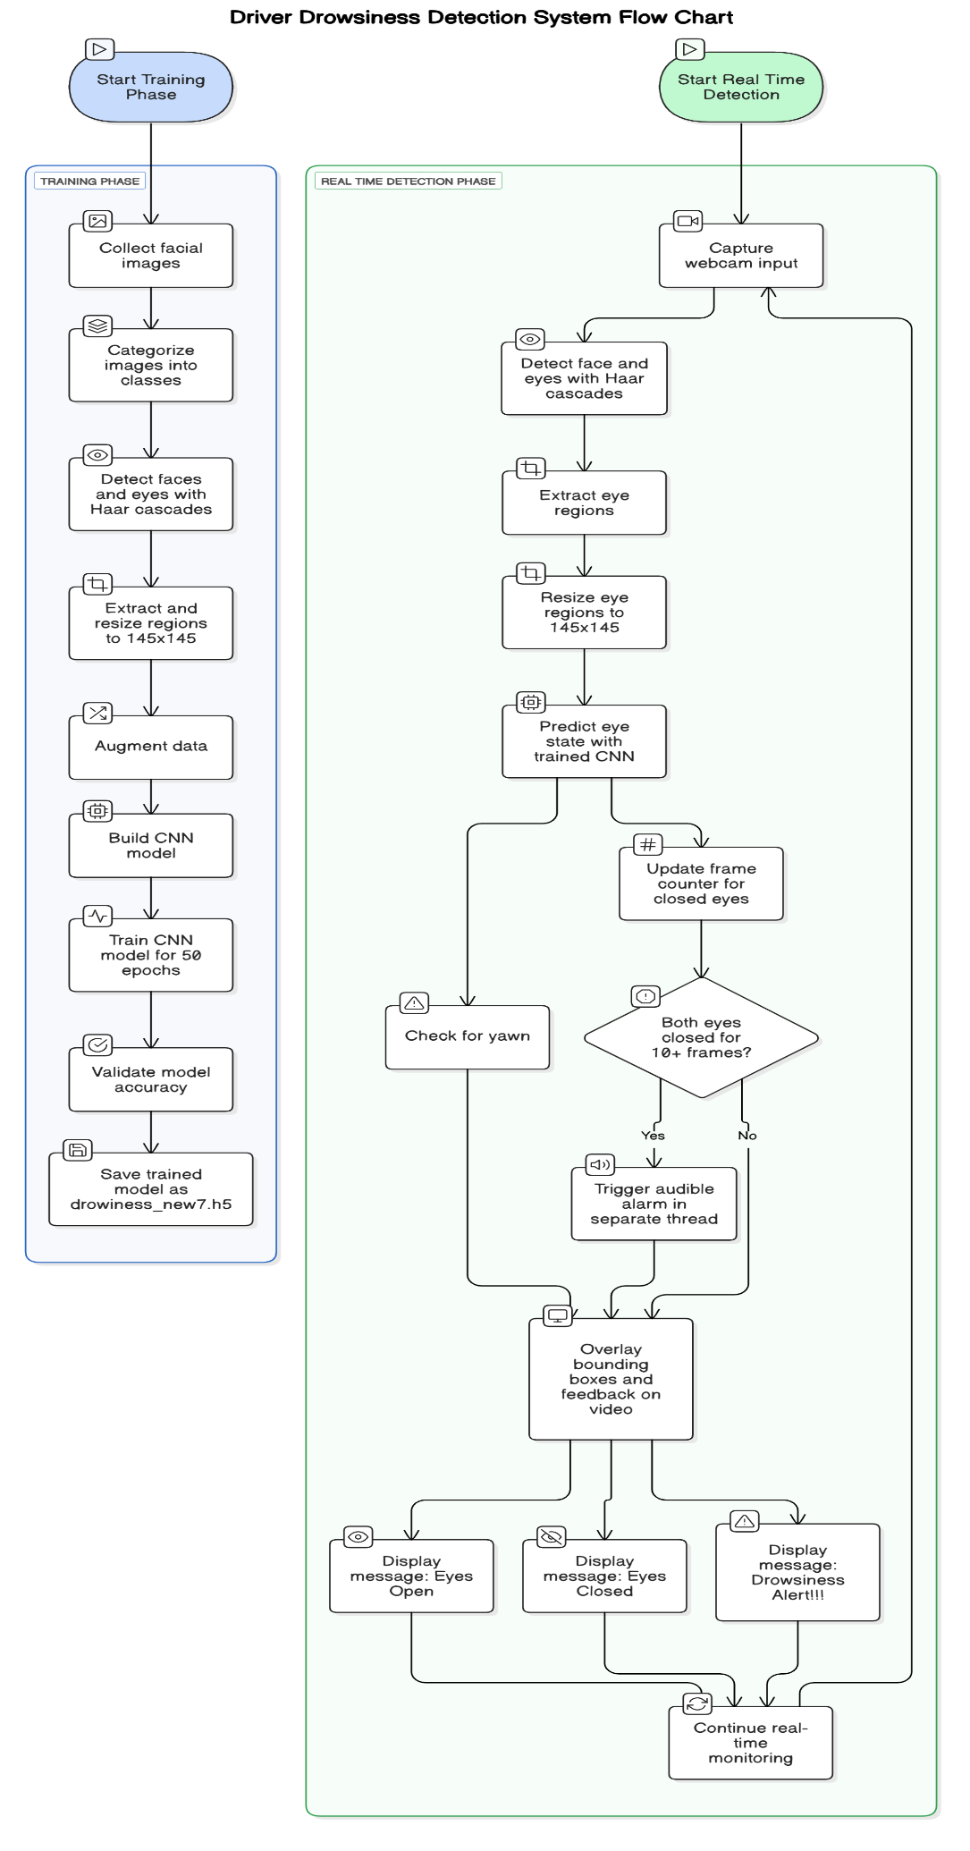
Fig.4. 3.1 SDN Architecture
4.4. CNN Model Architecture
CNNs are built on layers that extract increasingly abstract features from the input image. Here's a breakdown:

Architectural Layers and Their Purpose:
- Convolutional Layer:
  - Applies a set of learnable filters to the image.
  - Captures local patterns such as edges, textures, and corners.
- Activation Function (ReLU):
  - Introduces non-linearity.
  - Prevents the network from collapsing into a linear model.
- Max Pooling:
  - Downsamples the feature maps, reducing spatial dimensions.
  - Retains important features while reducing overfitting.
- Dropout Layer:
  - Randomly drops neurons during training.
  - Prevents over-reliance on specific neurons and improves generalization.
- Flatten Layer:
  - Converts 2D matrices into 1D vectors for fully connected layers.
- Dense Layer (Fully Connected):
  - Learns non-spatial combinations of features for classification.
- Softmax Output:
  - Converts raw scores into probabilities.
  - Ensures sum of outputs = 1, for multi-class classification.
This architecture ensures a balance between depth (feature richness) and speed (real-time feasibility).

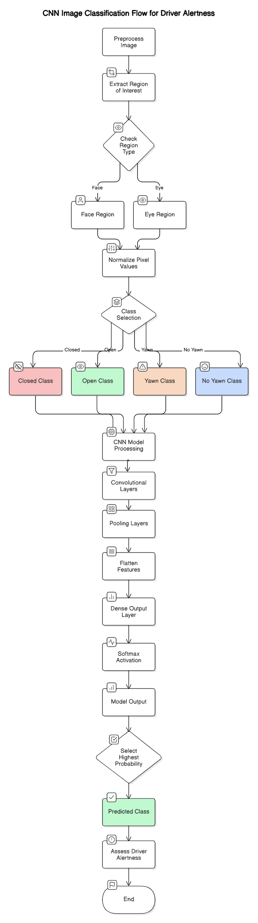
Fig.4. 4.1 CNN Architecture
4.5. Model Training and Evaluation
Training Setup:
- Optimizer: Adam (Adaptive Moment Estimation) — Combines momentum and RMSprop, suitable for sparse gradients.
- Loss Function: Categorical Cross-Entropy, appropriate for multi-class classification.
- Epochs: 50 (each epoch is one complete pass over the training data).
- Batch Size: Usually set between 16–64 depending on hardware constraints.
Metrics Interpretation:
- Training Accuracy: How well the model fits the training data.
- Validation Accuracy: Measures performance on unseen data.
- Training Loss: Indicates error on training samples.
- Validation Loss: High values here can indicate overfitting.
Observations:
- Gradual rise in accuracy and drop in loss indicate effective learning.
- Stable validation curves show that the model generalizes well.
- No drastic gap between training and validation implies minimal overfitting.

4.6. Real-Time Detection and Implementation
Technical Workflow:
- Captures live video using OpenCV.
- Applies Haar cascade detection for face and eye tracking in every frame.
- Crops eye regions and resizes them.
- Feeds frames into the trained CNN model.
- Based on model output, triggers alerts after:
  - 10+ frames of eyes closed.
  - Yawning detected multiple times in short intervals.
Output Mechanism:
- Visual Alert: “Drowsiness Detected!” text on screen.
- Auditory Alert: Buzzer or alert sound using playsound() or pygame.

Advantages:
- Lightweight for edge devices.
- Works in varying lighting conditions due to augmented training.
- Scalable for commercial vehicle fleets, public transport, and personal cars.
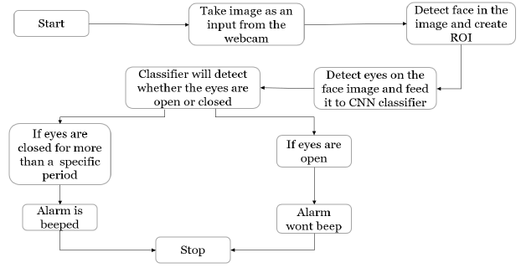
Fig.4. 6.1 Real-Time Detection

4.7. Results and Observations
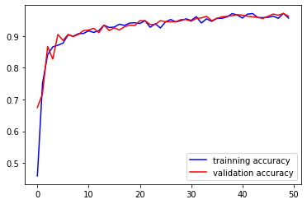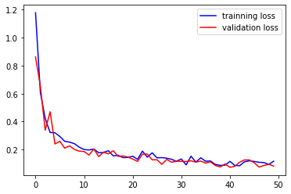
Fig.4. 1.1 Accuracy and Loss plots

Model Performance:
- Achieved >95% accuracy on test data.
- Fast inference time (<0.1s per frame).
- Successfully detected fatigue in controlled and semi-real environments.

Strengths:
- Real-time, frame-wise analysis.
- No external sensors required.
- Simple integration with vehicle dashboards or Raspberry Pi setups.
Limitations:
- Haar cascades may miss detections under extreme lighting or occlusions.
- Model may need retraining for individuals with glasses or facial coverings.

4.7. Challenges
Developing a Driver Drowsiness Detection System using Convolutional Neural Networks (CNNs) involved several technical and practical challenges, particularly in the real-time application of computer vision techniques. A primary difficulty was ensuring accurate and consistent face and eye detection under variable conditions. Real-world environments, such as the interior of a moving vehicle, introduce changes in lighting, facial angles, occlusions (like glasses or hats), and skin tone diversity—all of which can impair traditional feature-based detectors like Haar cascades. This required fine-tuning detection parameters and preprocessing techniques to improve robustness and minimize false detections, ensuring that the correct eye regions were extracted for classification by the CNN.
Another major challenge was the design and training of the CNN model itself. A balance had to be struck between computational efficiency and model accuracy. Larger, deeper models can achieve higher performance but are computationally expensive and slow, especially when deployed on devices with limited resources. Therefore, the architecture had to be lightweight enough to support real-time inference while still being capable of distinguishing subtle differences between open and closed eyes. To achieve this, multiple convolutional layers were used, followed by activation functions like ReLU, pooling layers to reduce dimensionality, and fully connected layers for final classification. Regularization techniques such as dropout and batch normalization were also applied to reduce overfitting and enhance generalization.
Beyond model design, integrating all system components into a cohesive, real-time application was a significant software engineering challenge. The pipeline required seamless coordination between webcam input, frame-by-frame analysis, CNN-based classification, and decision logic to track consecutive closed-eye frames and trigger an alarm. Efficient multithreading was implemented to avoid delays in video capture and prediction, and to ensure that the alarm system responded promptly when drowsiness was detected. Additionally, maintaining accuracy over long-duration use while preventing false alarms posed ongoing testing and optimization efforts. Together, these challenges spanned areas of AI, embedded systems, and real-time user interaction, highlighting the complexity and interdisciplinary nature of the project.
.

CHAPTER 5

Conclusion and Future Work

5.1 Conclusion
Driver drowsiness detection using computer vision and deep learning techniques is an essential contribution to intelligent transportation systems and road safety. The project developed a real-time detection system that leverages convolutional neural networks (CNNs) to classify four distinct states—open eyes, closed eyes, yawning, and no yawning—based on facial features, specifically eye and mouth movements. The system was trained on a carefully preprocessed dataset, and a model was built that integrates Haar cascade classifiers for face and eye detection with a custom CNN for classification.
The achieved validation accuracy (~96%) highlights the model’s ability to generalize on unseen data, demonstrating its suitability for practical scenarios. The system also successfully integrates alarm-based feedback to alert drowsy drivers, combining both software intelligence and user safety response. This hybrid design, involving classical image processing (for face/eye localization) and deep learning (for behavior classification), proved to be effective and modular.
However, despite its success, the model has certain limitations rooted in real-world unpredictability, including changes in lighting, facial occlusions, and subtle behavioral variations. The CNN, although effective, still relies on supervised training, which requires a robust and diverse dataset. Overall, the project not only showcases the technical feasibility of real-time drowsiness detection but also opens up opportunities for enhancement through multi-modal input and adaptive learning systems.

5.2 Future Scope
- Integration With Infrared Cameras for Night

Traditional RGB cameras struggle in low-light conditions. Integrating infrared (IR) cameras can help monitor eye and facial features even at night, making the system functional 24/7 regardless of lighting conditions.

- Incorporation of Head Pose

Adding head pose estimation will enhance accuracy by identifying signs of micro-sleep (e.g., head nodding or tilting). This can serve as an additional cue for detecting drowsiness, even if eyes are partially open.

- Multi-Modal Sensing

Combining vision-based detection with physiological sensors (e.g., heart rate, EEG) and behavioral data (like steering wheel movements) can provide a more comprehensive and reliable assessment of driver alertness.

- Model Optimization for Edge Deployment

Optimizing the model using techniques such as quantization, pruning, or knowledge distillation can reduce inference time and memory usage, making the system deployable on embedded devices like Raspberry Pi or NVIDIA Jetson
.
- Dynamic Thresholding and Temporal Analysis

Instead of relying on static thresholds (like number of frames with closed eyes), implementing temporal models (e.g., LSTM, GRU) could detect patterns over time, improving reliability for long-duration fatigue detection.

- User Personalization and Adaptive Learning

Future versions can include adaptive learning to personalize the model based on individual users. By learning from a specific driver's patterns, the model could reduce false positives and increase accuracy over time.

References
- Rateb Jabbar et al., “Driver Drowsiness Detection Model Using CNN Techniques for Android Application” – 2021.
Describes a lightweight CNN model implemented on Android to monitor driver fatigue through eye state detection.
- Soumya Agarwal, Dr. M.N. Nachappa, “Driver Drowsiness Detection System Using CNN” – IJSET, Vol. 10, Issue 2, 2022.
Proposes a CNN-based system to classify driver alertness using image inputs with real-time application focus.
- Wilson Florez et al., “Facial Region of Interest Based Driver Drowsiness Detection Using CNN Models” – Applied Sciences (MDPI), 2023.
Utilizes a region-of-interest approach with CNNs to isolate facial features critical for fatigue detection.
- Md. Iqbal Hasan et al., “Real-Time Driver Drowsiness Detection Using Facial Features and Deep Learning” – IEEE Access, Vol. 9, 2021.
Combines Haar cascades for detection and deep CNN for classification, tested in real-world driving environments.
- Abdul Wahid et al., “Deep Learning-Based Drowsiness Detection Using Eye Aspect Ratio and CNN” – Procedia Computer Science, Vol. 189, 2021.
Integrates classical eye aspect ratio (EAR) techniques with CNN classification for better performance.
- M. Pourya Rikhtegar et al., “Drowsy Driver Detection Based on Yawning Analysis Using CNN” – 2020, IEEE International Conference on Image Processing.
Focuses on yawning behavior using facial landmarks and CNN-based classification models.
- Aashima et al., “Driver Drowsiness Detection System Using Image Processing and CNN” – International Journal of Engineering Research & Technology (IJERT), Vol. 9, Issue 7, 2020.
Explores the preprocessing pipeline along with CNN-based classification of eye states.
- Pawel Woznowski et al., “Real-Time Eye State Detection for Driver Drowsiness Monitoring Using Deep Convolutional Neural Networks” – Sensors (MDPI), Vol. 22, 2022.
Employs advanced CNN architectures and pre-trained models for eye state detection in varied lighting conditions.
- K. Bhandari, A. Sharma, “Eye Blink Detection Using CNN for Drowsiness Detection” – International Journal of Computer Applications, Vol. 182, No. 46, 2019.
Focused solely on blink frequency and eye closure using CNNs for early drowsiness symptoms.
- T. Sanjeev, A. Arora, “Real-Time Driver Drowsiness Detection System Using Deep Learning Techniques” – 2022, International Journal of Computer Sciences and Engineering.
Presents an end-to-end deep learning pipeline from video input to drowsiness alerts, emphasizing system latency and accuracy.

Annexure I

Plagiarism Report

